CISC7204
Data Science & Data Visualization
ASSIGNMENT 01 — PRELIMINARY PROJECT PROPOSAL
Money and Happiness in America: Income, Subjective Well-Being, and Economic Growth (1972–2024)
• UN CHI KIT (mc653081) • Kelden Jamtsho (mc664183)
Pair Work • Submission deadline: 20 September 2026, 11:00 pm

Project Topic Name
Money and Happiness in America: Does Income Buy Happiness? (1972–2024)

Precisely Written Research Question
In the United States of America, how is family income associated with self-reported happiness, and how has this relationship, and the national level of reported happiness, changed between 1972 and 2024 as the country became substantially richer?

Region and Domain Category
- Region: United States (national sample of General Social Survey respondents, 1972–2024).
- Domain category: Subjective well-being (happiness), family income, and national economic growth.

Available Datasets
Dataset 1 — General Social Survey (GSS), NORC, 1972–2024. Provides individual-level happiness (HAPPY), family income (REALINC), and control variables including age, sex, and education. The notebook uses 35 published waves and retains 64,848 respondents after validity filtering.
- GSS data download page - https://gss.norc.org/Get-The-Data
- GSS cumulative Stata file - https://gss.norc.org/content/dam/gss/get-the-data/documents/stata/GSS_stata.zip
Dataset 2 — World Bank GDP per capita, United States. Indicator NY.GDP.PCAP.KD, GDP per capita in constant 2015 US dollars, used as the national economic-growth benchmark.
- World Bank indicator page https://data.worldbank.org/indicator/NY.GDP.PCAP.KD?locations=US
- World Bank API used by the notebook - https://api.worldbank.org/v2/country/USA/indicator/NY.GDP.PCAP.KD?format=json&per_page=1000&date=1972:2024

Justification: how the visualization addresses the research question
The visualization is designed around two complementary analyses. First, the GSS is used at the respondent level to examine whether people with relatively higher family income report higher happiness than people with relatively lower family income at the same point in time. Because GSS real-income values are banded and the deflator base changes across releases, the notebook ranks respondents into five income quintiles within each survey year. Pooling all 35 waves gives 64,848 usable respondents. The resulting distribution shows a monotonic increase in the share reporting “very happy,” from 20.7% in the poorest quintile to 39.7% in the richest. The association is statistically significant (χ²(8) = 2861.3, p<1×10⁻³⁰⁰), with Cramér’s V=0.149 and a richest-versus-poorest odds ratio of 2.52 (95% CI 2.39–2.66). The 2024 regression comparison also shows that the income gradient remains statistically significant after controlling for age, sex, and education.
Second, the project examines the time dimension separately. World Bank GDP per capita increased from approximately $26,799 in 1972 to $66,857 in 2024, a 2.49× increase. Over the same endpoints, the GSS share reporting “very happy” changed from 30.3% to 19.8% (−10.5 percentage points). Across the 35 survey waves, the association between GDP per capita and the percentage reporting “very happy” is negative (Spearman ρ=−0.663, p<0.0001), while the pre-2022 happiness trend is also negative (Kendall τ=−0.473, p=0.0001). The visual therefore presents both the within-year income–happiness gradient and the long-run national time series, rather than treating them as the same question. The interpretation remains associational: the data do not establish that changes in an individual’s income cause changes in happiness.
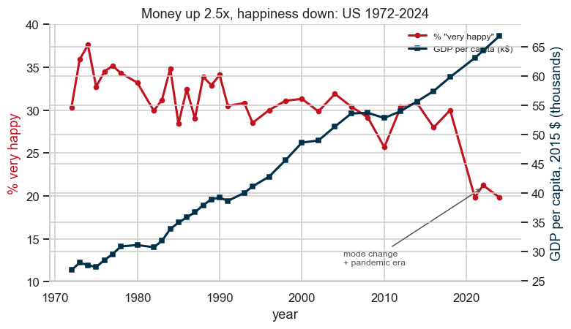

Figures Produced by the Notebook
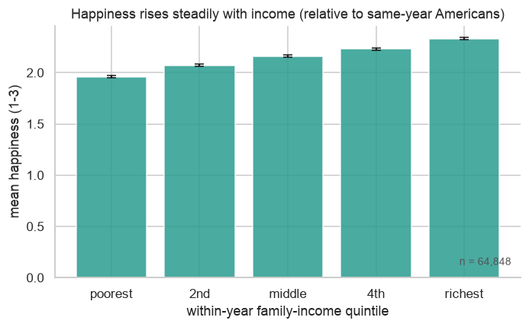
Figure 1 — Income–happiness gradient: mean happiness by within-year income quintile, with 95% confidence intervals.
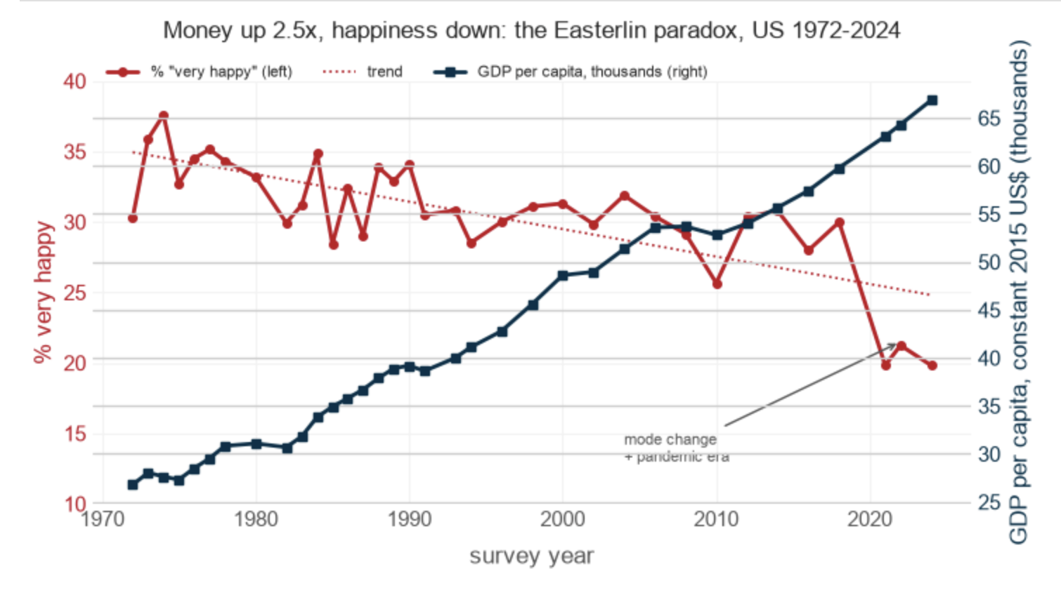
Figure 2 — Happiness versus GDP per capita over time: a dual-axis time series covering 1972–2024, with the recent survey-mode change explicitly identified.
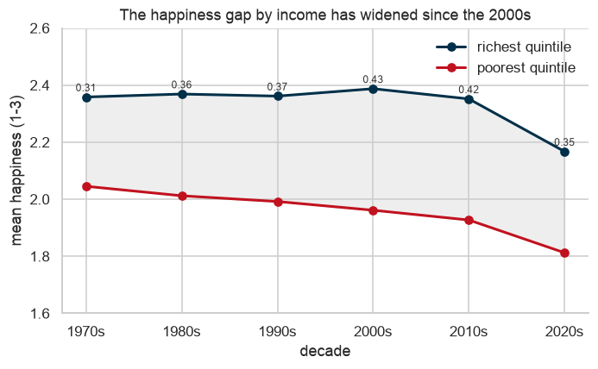
Figure 3 — Rich–poor happiness gap by decade: comparison of the poorest and richest income quintiles across the study period.
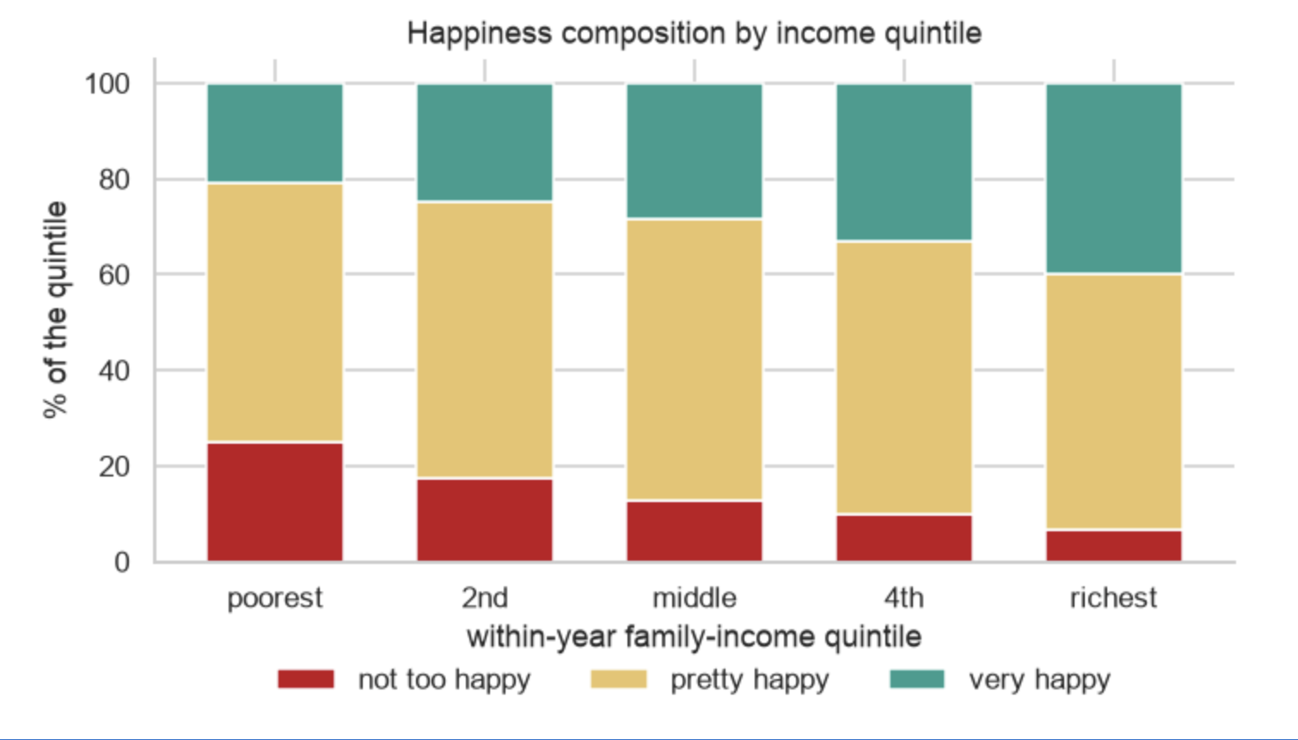
Figure 4 — 2024 happiness composition: the proportions reporting very happy, pretty happy, and not too happy within each income quintile.

Project Purpose

5.1 Outcomes
- Apply a complete data-science workflow to public real-world datasets: acquisition, cleaning, exploratory analysis, statistical testing, visualization, and interpretation.
- Demonstrate course learning outcomes related to importing and wrangling real survey/statistical data and producing clear, evidence-based visualizations.
- Develop experience relevant to future study or career work in social-science research, data analysis, and data-driven storytelling.

5.2 Skills
- Python 3 data wrangling with pandas and numerical processing with NumPy.
- Statistical analysis using chi-square tests, Spearman/Kendall correlations, ordinary least squares regression, odds ratios, effect sizes, and confidence intervals.
- Data visualization using Matplotlib/Seaborn and development of an interactive results presentation.
- Reproducible analysis: keeping the notebook, data-processing steps, statistical results, and figures connected.

5.3 Knowledge
- Survey-data analysis and interpretation of subjective well-being measures.
- Income–well-being research and the distinction between cross-sectional association and long-run national trends.
- Practical issues in real datasets: missing values, banded income measures, changing deflator bases, survey-mode changes, sampling gaps, and causal/ecological inference limitations.

Project Tasks

6.1 Data acquisition
- Obtain the GSS yearly Stata files and World Bank GDP-per-capita data used by the notebook.

6.2 Data cleaning
- Keep valid HAPPY and REALINC responses.
- Recode happiness to an ordered 1–3 scale.
- Check for unusable or missing values.

6.3 Income normalization
- Create five within-year family-income quintiles.
- Compare respondents with others interviewed in the same survey wave.

6.4 Exploratory analysis
- Summarize happiness by income quintile and survey year.
- Inspect the distribution and time coverage.

6.5 Statistical testing
- Use chi-square, correlation, regression, effect-size, odds-ratio, and confidence-interval calculations to quantify the observed relationships.

6.6 Time analysis
- Compare happiness trends with World Bank GDP per capita.
- Examine whether the direction is robust when recent survey-mode changes are excluded.

6.6 Visualization
- Produce four publication-quality static figures.
- Create an interactive HTML results page with captions, labels, and supporting statistics.

6.7 Reproducibility and review
- Ensure all reported values can be reproduced from the Python 3 notebook.
- Review the code, figures, wording, and methodological caveats before submission.

Project Criteria for Success

7.1 Research question alignment
- Every visual directly addresses either the income–happiness relationship or its change over time.

7.2 Data completeness
- The analysis uses all 35 GSS waves identified by the notebook that contain the required variables, with 64,848 usable respondents after filtering.

7.3 Statistical support
- Important quantitative claims are accompanied by appropriate test statistics, effect sizes, or confidence intervals.

7.4 Visual clarity
- Figures have readable titles, axes, legends, units, and captions.
- Each figure can be understood without relying on the code.

7.5 Reproducibility
- The Jupyter Notebook can reproduce the reported numbers and figures from the stated public datasets.

7.6 Interpretive accuracy
- The proposal distinguishes association from causation.
- Income-band, survey-mode, pandemic-era, and sampling limitations are explicitly documented.

7.7 Deliverables
- Four static figures.
- One interactive HTML results page.
- Python 3 Jupyter Notebook.
- Required written justification.
- All deliverables are complete and ready for submission.

Submission / Quality Checklist
- Region and domain category stated.
- One precise research question stated.
- At least two dataset links provided.
- Optional figures included as supporting visual evidence.
- 1 - 2 paragraph visualization justification included.
- Jupyter Notebook identified as the reproducibility artifact.
- Project purpose covers outcomes, skills, and knowledge.
- Tasks include concrete steps and deliverables.
- Criteria for success are explicit and testable.
- Collaboration division, ground rules, and roles are stated.

Project Collaboration
The project proposal is a two-person pair project. The following division is proposed to make responsibilities clear while retaining peer review by both members.
Member | Primary responsibilities
UN CHI KIT (mc653081) | Data acquisition and cleaning; statistical testing; Python/Jupyter Notebook; reproducibility checks.
Kelden Jamtsho (mc664183) | Visualization design; figure captions; interactive results page; written proposal/justification.

9.1 Ground Rules
- Conduct a weekly progress check and keep the shared code/data repository synchronized from the beginning.
- Agree on the research question and analysis definitions before interpreting results.
- Each member reviews the other member’s code, figures, and written sections before submission.
- Use reproducible source data and document any change to code, variables, filters, or visual design.
- Do not use causal wording when the analysis only establishes statistical association.

References
NORC at the University of Chicago. General Social Survey (GSS), 1972–2024.
https://gss.norc.org/Get-The-Data
Easterlin, R. A. (1974). Does economic growth improve the human lot? Some empirical evidence. In P. A. David & M. W. Reder (Eds.), Nations and households in economic growth: Essays in honor of Moses Abramovitz (pp. 89–125). Academic Press. https://doi.org/10.1016/B978-0-12-205050-3.50008-7
World Bank. (n.d.). GDP per capita (constant 2015 US$) – United States. World Development Indicators. Retrieved September 17, 2026, from https://data.worldbank.org/indicator/NY.GDP.PCAP.KD?locations=US
Declaration of AI Usage
    - Did I use an AI LLM? Yes
    - Exact LLM used: ChatGPT – 5.6 Luna, DeepSeek – V4 Flash
    - Web Browser used: Google Chrome at chatgpt.com

